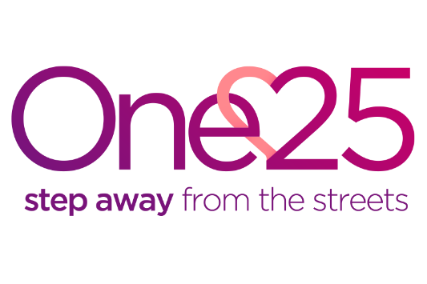

Bristol Sexual Violence Forum
Confidentiality Agreement
Chair of this forum is Anna Smith, CEO One25
THE PURPOSE OF THIS MEETING IS AS FOLLOWS:
- To share information to increase the safety, health and well being of victims – adults and their children;
- To present cases of individuals at high risk who have experienced sexual violence and who are of particular concern to that agency or member of the forum;
- To risk assess and categorise each case by ‘Appendix 1: Risk rating for SVF’, these cases will be reviewed and subject to change every forum;
- The aim is to make at risk individuals safer and provide a coordinated response with actions leading from this meeting;
- To improve agency accountability;
- Improve support for staff involved in high risk sexual violence cases;
- Actions highlighted will be sent out with minutes in the view that they will be completed, or an update will be brought to the next forum. The responsibility to take appropriate actions is not transferred to the Bristol Sexual Violence Forum. The role of the forum is to facilitate, monitor and evaluate effective information sharing to enable appropriate actions to be taken to increase public safety.
All information discussed and presented at this forum is strictly confidential and must not be disclosed to third parties without the agreement of the partners of this meeting.
Information shared should focus on sexual violence concerns. A clear distinction should be made between fact and opinion.
All attendees of the forum must take responsibility to ensure that all documentation and passwords protecting documentation
All documentation will aim to reflect that all individuals who are discussed at these meetings should be treated fairly, with respect and without discrimination.
All work undertaken at this forum will be informed by a commitment to equal opportunities and effective practice.

BY SIGNING THIS DOCUMENT YOU AGREE TO ABIDE BY THESE PRINCIPLES
Signed:
Name (in capitals):
Date:

