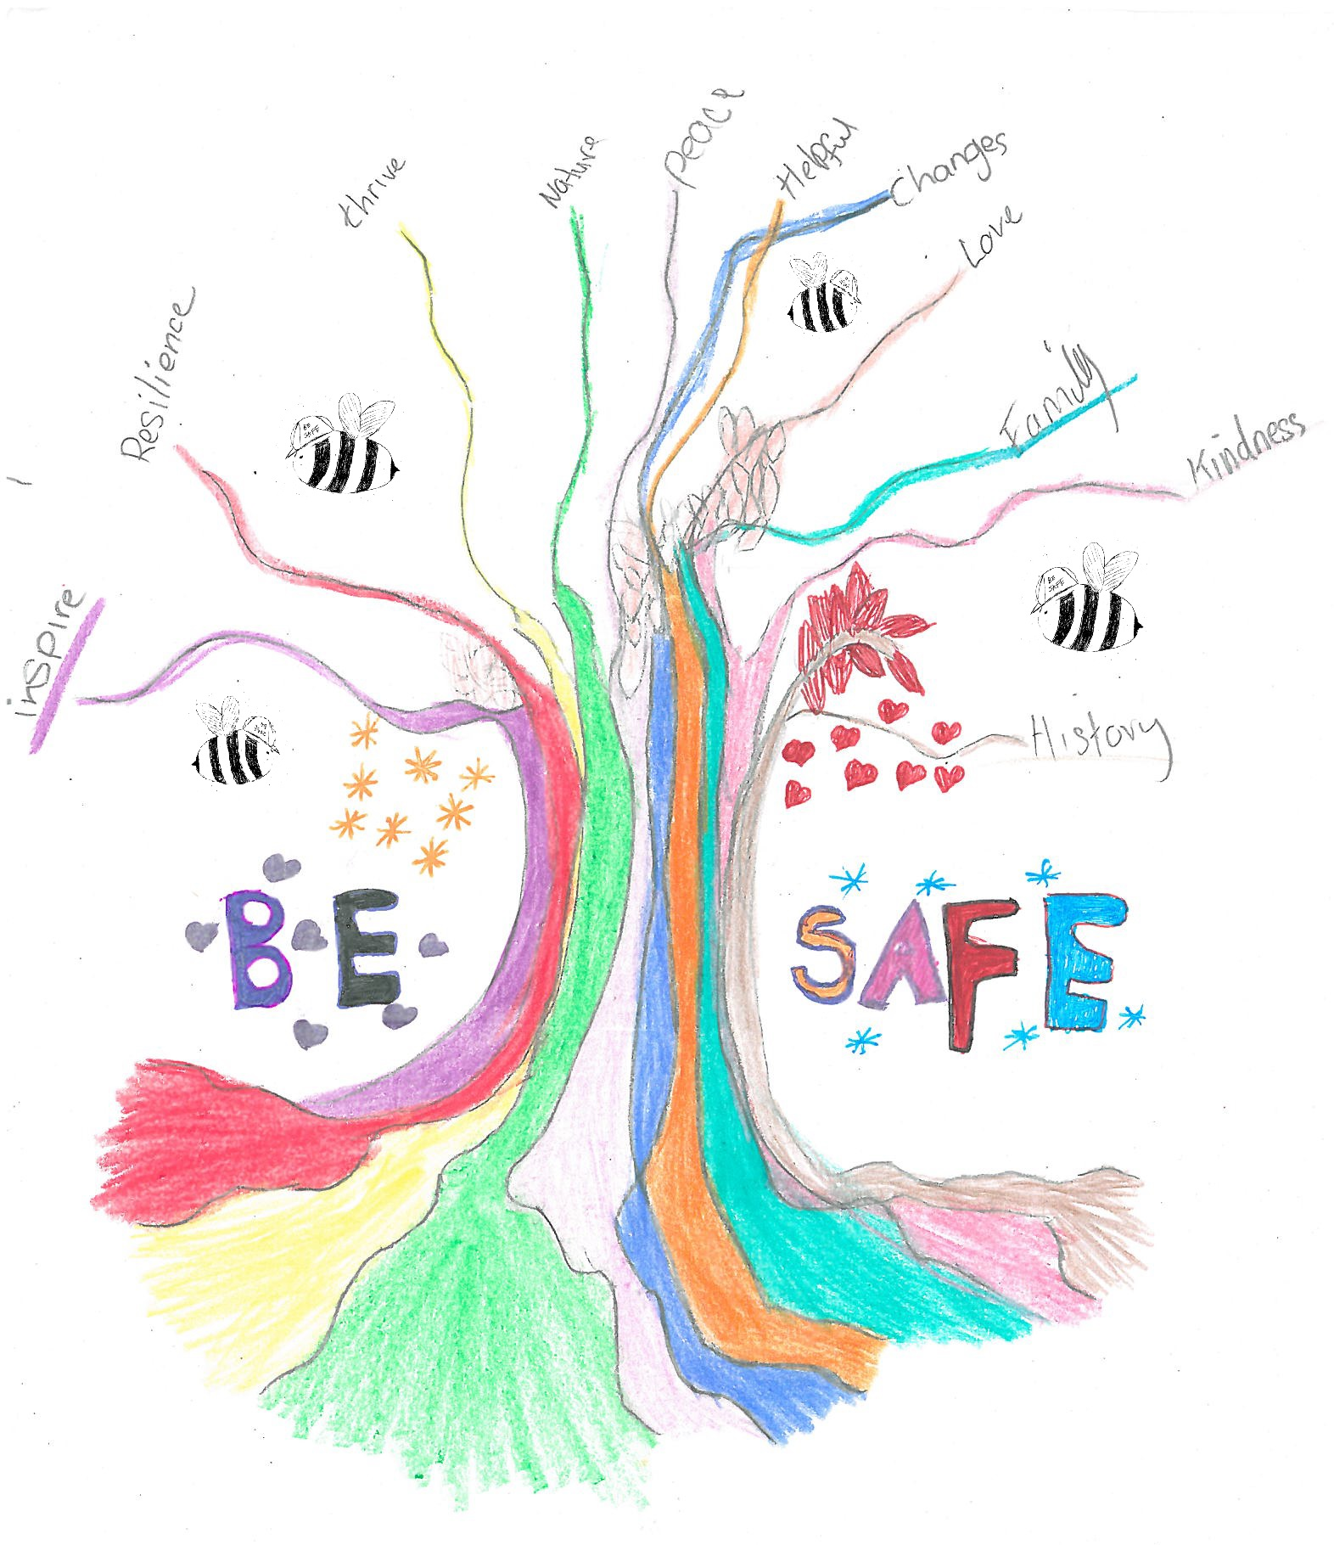
BE SAFE 3 DAY VIRTUAL CONFERENCE
Tuesday 15th June 2021
Wednesday 30th June 2021
Thursday 15th July 2021

LEARNING FROM PRACTICE:

Working with children and young people who have harmed sexually, their families and support networks.

Themes:
Day 1: Partnership Responses
Day 2: Challenging Barriers
Day 3: Working With Families

Hosted on MS Teams, the cost of this conference per person is:
£60.00 for 1 day
£100.00 for 2 days
£120.00 for 3 days
10% discount for block bookings of 10+
This conference is organised by the multi-agency partnership Bristol Be Safe Service. Be Safe works with children and young people where there are concerns regards their problematic/harmful sexual behaviour, their parents/carers and their support network. Be Safe, with a CQC outstanding rating in a number of areas, and a National Health Care Award 2020 for partnership working has been involved in collaborative innovations since being established in 2008. We wish to share our learning since that time, and consider the current evidence base. The conference is aimed at health, mental health, criminal justice, social care, and education professionals and commissioners, as well as foster carer and residential providers, who are concerned about children and young people’s problematic and harmful sexual behaviour. You may wish to choose one, two or three days of the conference which addresses partnership working, working to address barriers and working with families. There will be a series of 60-90 minute presentations with a chance for questions.

DAY 1 – 15th June 2021: Partnership Responses
10am-11am - Multi-agency working with children and young people who have engaged in problematic/harmful sexual behaviour and their parents/carers

11.30am-12.30pm - Tackling HSB and managing risk in school settings

1.30pm-2.30pm - Responding to Young People who have engaged in Technology Assisted Harmful Sexual Behaviour

3pm-4pm - Working virtually with children and young people who have engaged in problematic/harmful sexual behaviour and their parents/carers – The Be Safe Think Safe Virtual Programme

DAY 2 – 30th June 2021: Challenging Barriers
9.30am-11am – Working with young people with learning disabilities who have engaged in harmful sexual behaviour and their parents/carers – a brief introduction to the Keep Safe Programme, a group and family intervention

11.30am-1pm – Challenging barriers to services for the BAME (Minoritised) Communities

2pm-3.30pm – Considering trauma when working with children and young people who have engaged in problematic/harmful sexual behaviour

3.45pm-4.15pm – Plenary Q&A

DAY 3 – 15th July 2021: Working with Families
9.30am-11am – Responding to sibling sexual abuse

11.30am-1pm – Working with families where a child/young person has engaged in problematic/harmful sexual behaviour

2pm-3.30pm – Focus on Foster Care: Supporting foster carers caring for children/young people who are traumatised and who display problematic/harmful sexual behaviour

3.45pm – 4.15pm – Plenary Q&A

Presenters include the following from the Be Safe team and partner agencies:-

- Stephen Barry – Be Safe Lead Clinician/Clinical Team Manager
- Alice Hunt – Be Safe Senior Specialist Therapist
- Dr. Anna Fussell – Thinking Allowed Clinical Psychologist
- Dr. Tilly Langton – Be Safe Clinical Psychologist
- Paul Kelly – Be Safe Family Therapist
- Jonathan Beavis – Be Safe Assistant Psychologist
- Laura Stephens – Be Safe Therapeutic Practitioner
- Sayi Thomas – Child and Adolescent Psychotherapist
- James Gregory – Bristol City Council School Safeguarding Advisor

Application process:

If you would like to attend this conference please complete the attached application form and return it before 1 June 2021 to

Email: learninganddevelopment.awp@nhs.net
If block booking required please email the above address.

Application Form:

Hosted on MS Teams

Be Safe Conference The cost of this conference per person is: £60.00 for 1 day, £100.00 for 2 days, £120.00 for 3 days
10% discount for block bookngs of 10+
If block booking required please email the above address.
Please help us to help you by answering all questions and printing clearly.

Applying for a course does not guarantee you a place. Once we have completed the short listing process we will contact you to confirm the outcome of your application by email. If you do not have regular access to emails please give your manager’s email address for this purpose.

Date | Theme | Indicate which day(s) you are applying for
Day 1 – 15th June | Partnership Responses
Day 2 – 30th June | Challenging Barriers
Day 3 – 15th July | Working With Families
TOTAL COST |  | £

Please give us information about you:
Full Name: | Work Email address:
Role: | Clinical delivery unit/Locality:
Work Team/Dept/Ward: | Work address & postcode:
Email address: | Work Tel No:
Mobile Telephone Number
Your Signature: | Managers Signature (if applicable):
PLEASE NOTE WE CANNOT ACCEPT THE APPLICATION UNLESS ALL INVOICE BOXES ARE FULLY COMPLETED. | Department address for invoicing:
Contact Name for invoice: | PURCHASE ORDER NUMBER (NB. No place will be offered without this number)

Equalities:
To help us ensure that events are accessible please tell us of any particular needs you may have in relation to the event, e.g. diet, mobility, hearing or visual impairments, arrival and departure time, withdrawal at short notice, etc.

Please email your completed application form to:
learninganddevelopment.awp@nhs.net

Course Administrator:

Learning & Development
AWP – Kingswood Civic Centre
High Street
Kingswood
Bristol
BS15 9TR
Tel: 0117 354 6011 or 6003
Email: learninganddevelopment.awp@nhs.net

