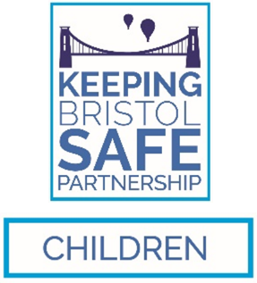
Allegations against a person who works or volunteers with children

Referral / Request for Consultation

This form is to be completed on every occasion when an allegation is made against a member of staff, volunteer, or foster carer.

Form to be sent to the Local Authority Designated Officer within one working day
of the allegation being reported

Please email the completed form to LADO@bristol.gov.uk

Details of the person completing this form
Name
Job Title
Organisation
Email address
Telephone No. |  | Date

Details of the professional or volunteer against whom the allegation or concern has been raised
Full Name |  |  |  | Date of Birth
Home Address
Role |  |  |  | Length of employment
Employer or Organisation
Place/base of work
Does the person work or volunteer with children in another setting? [provide details]

For agency staff – please provide the name of the agency, a contact name, and a telephone number or email address | Has the agency been notified? | Y / N

Details of the child

[if the complainant is an adult raising historic concerns, please enter their details here]
Full Name |  |  | Date of Birth
Home Address
Name of Parent and contact details
Lead professional contact details i.e. social worker

Details of any children with whom the adult has contact outside of their employment
[e.g. their own children, partner’s children, family members etc.]
Names:
DOBs:
Address
(if different to above)
Relationship to the professional / volunteer

Which of the following criteria do you consider the allegation meets? tick all that apply
Has harmed or may have harmed a child?
Is possibly a criminal offence against or related to a child?
Indicates the individual poses a risk of harm to children?
Behaved in a way that indicates they may not be suitable to work with children?
OR:
I am unsure and I am seeking advice and guidance

Incident or concern
Date and time of incident:
Location of incident:
Summary of the incident
[please provide as much information as possible including what led up to the incident, any witnesses, evidence of harm, any actions taken?]
Previous concerns or allegations regarding the professional or volunteer
Information about the child or young person
[How was the child behaving, have they made previous allegations, do they have a disability, SEN etc]
Any other relevant information you wish to provide

Please email the completed form to LADO@bristol.gov.uk

